Little Rascals Permission Form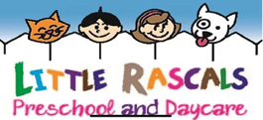

<https://www.lemarslittlerascals.com/>

*****PLEASE INITIAL BESIDE EACH STATEMENT THAT APPLIES TO YOUR CHILD*****

_____ Yes, I give my permission for my child ___________________________’s Photograph/and or video to be taken and may be used for our class website, local newspaper, or Facebook page.

_____ No, my child _____________________________’s photograph/and or video may not be taken.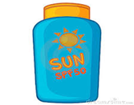

________ Yes, I give my permission for my child to have applied sunscreen to them when conditions allow. If you would like to supply your own, please bring a labeled container to the facility.

________ No, I do not wish for my child to have sunscreen applied to them when in Little Rascals care.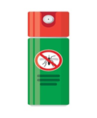

If conditions require, Little Rascals will be responsible for the application of sunscreen or bug spray, upon your signed release.

________ Yes, I give my permission for my child to have applied bug spray to them when conditions allow. If you would like to supply your own, please bring a labeled container to the facility.

________ No, I do not wish for my child to have bug spray applied to them when in Little Rascals care.